HOW TO PREPARE FOR A DISASTER, AND HOW TO RESPOND

*All personnel will keep their NGST NCOIC or OIC informed on their contact and emergency contact numbers.

*Upon learning of or experience of an incident that would cause a call up of personnel to support the need for VDF personnel. It is the duty of every member to first ensure the safety needs for their individual family members of their immediate family before volunteering to duty.

*After assessment of family safety needs, individual personnel will contact their NGST NCOIC or OIC and advise them of their availability to support operations or unavailability.

*Personnel will use any means available to them to communicate their availability to their NGST NCOIC or OIC. Examples of possible communication media are:

On Star communication links
Satellite telephones
Cell telephones
Land line telephones
Arrival at a predetermined rally point designated by the NGST OIC

*NGST OIC will report to G3 the numbers of available personnel and functional capability of their NGST, and then await mission assignment from the G3 TOC.

*VDF G1: Will manage all administrative requirements.

*VDF G3: Will issue OPORD in support of emergency operations.

*VDFG4: Coordinate equipment issue for participating soldiers.

*All: Transportation is the member’s responsibility until at duty station. Consider carpooling with other VDF..

*NGST OIC or NCOIC will provide telephonic report to the G3 TOC daily during Emergency State Active Duty (ESAD).

*Member equipment/uniform: TRU’s with seasonal weather clothing. Member should maintain 72-Hour Load Pack.

*Messing: Each solder will maintain 3 days’ worth of MRE’s (9 individual MRE packages) . (Member is advised to maintain a week of vacuum sealed water and food for family at home).

*Billeting: To Be Determined (TBD) IAW with Mission assignment.

Make sure your family has a plan in case of an emergency. Before an emergency happens, sit down together and decide how you will get in contact with each other, where you will go and what you will do in an emergency. Keep a copy of this plan in your emergency supply kit or another safe place where you can access it in the event of a disaster. Enclosure (13)
Out-of-Town Contact Name: Telephone Number:
Email:
Neighborhood Meeting Place:
Telephone Number:
Regional Meeting Place:
Telephone Number:
Evacuation Location:
Telephone Number:
Fill out the following information for each family member and keep it up to date.
Name:
SocialSecurityNumber:
DateofBirth:
ImportantMedicalInformation:
Name:
SocialSecurityNumber:
DateofBirth:
ImportantMedicalInformation:
Name:
SocialSecurityNumber:
DateofBirth:
ImportantMedicalInformation:
Name:
SocialSecurityNumber:
DateofBirth:
ImportantMedicalInformation:
Name:
SocialSecurityNumber:
DateofBirth:
ImportantMedicalInformation:
Name:
SocialSecurityNumber:
DateofBirth:
ImportantMedicalInformation:
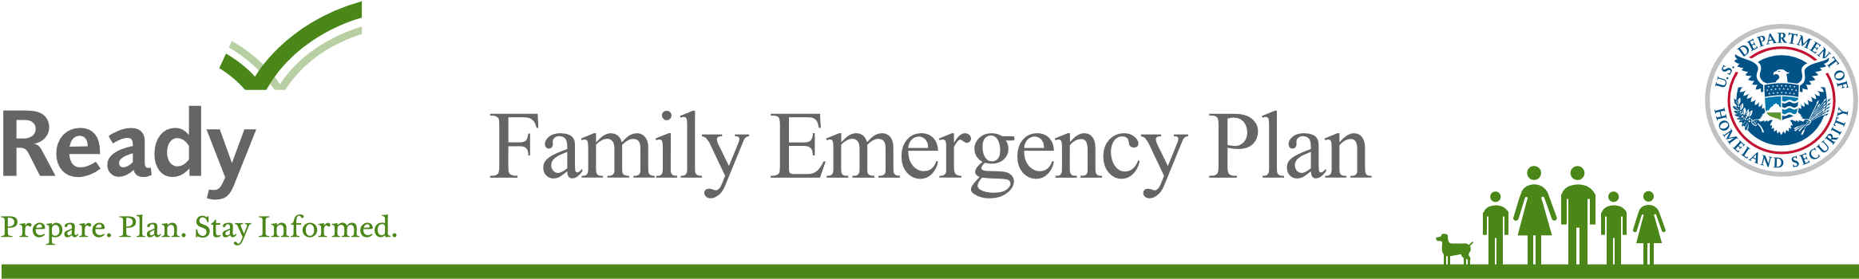
Write down where your family spends the most time: work, school and other places you frequent. Schools, daycare providers, workplaces and apartment buildings should all have site-specific emergency plans that you and your family need to know about.
Work Location One
Address:
PhoneNumber:
EvacuationLocation:
Work Location Two
Address:
PhoneNumber:
EvacuationLocation:
Work Location Three
Address:
PhoneNumber:
EvacuationLocation:
Other place you frequent
Address:
PhoneNumber:
EvacuationLocation:
School Location One
Address:
PhoneNumber:
EvacuationLocation:
School Location Two
Address:
PhoneNumber:
EvacuationLocation:
School Location Three
Address:
PhoneNumber:
EvacuationLocation:
Other place you frequent
Address:
PhoneNumber:
EvacuationLocation:

ImportantInformation
Name
Telephone Number
Policy Number
Doctor(s):
Other:
Pharmacist:
MedicalInsurance:
Homeowners/RentalInsurance:
Veterinarian/Kennel(forpets):
Dial 911 for Emergencies
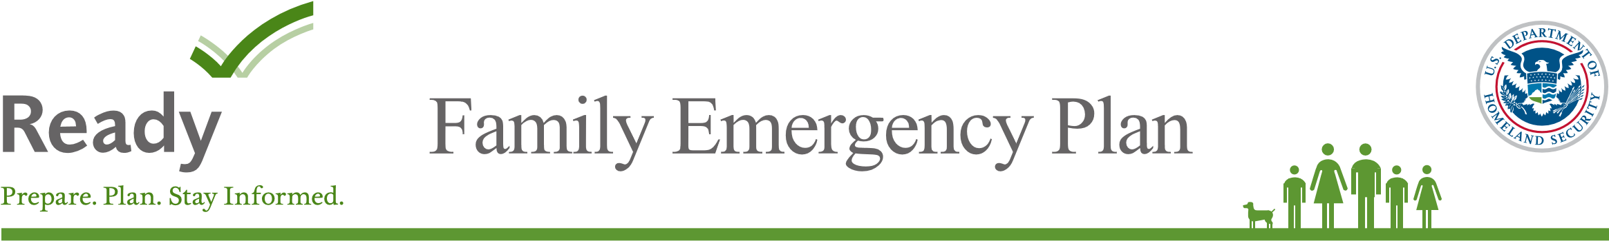
Make sure your family has a plan in case of an emergency. Fill out these cards and give one to each member of your family to make sure they know who to call and where to meet in case of an emergency.
