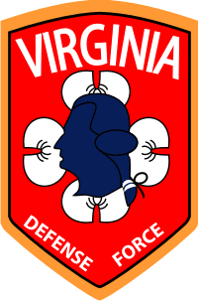
Virginia Defense Force
Senior Leadership Course

Purpose
Non-Commissioned Officer (NCO) Leadership is crucial to the success of the Virginia Defense Force (VDF), effective leaders are not born they are trained, re-trained, and trained again until they are ready confident to lead from the front. The Senior Leadership Course (SLC) will be the third course of many leadership courses in the VDF Noncommissioned Officer Education System (NCOES). Upon promotion to E-6 the VDF Soldier automatically will be enrolled into SLC. The projected length of time to complete SLC is 24 months, at which time the VDF Soldier is eligible to compete for E-7.

Timeline (80 hours total)

Phase I, first 12 months
• Distant Learning (DL)
- FEMA courses completion:
- IS 240: Leadership and Influence
- IS 242: Effective Communication
- IS 244: Developing and Managing Volunteers (Final course in FEMA Professional Development Series Certificate)
- IS 1300: Introduction to Continuity of Operations
- IS 2900: National Disaster Recovery Framework (NDRF) Overview
• Drill & Ceremony
- Online manual study, monthly practical exercise at home station with E-7 / E-8 approximately 30 min.
- Practical Exam at home station with E-8
- Final Exam at RTI MUTA

Phase II, Second 12 months
• Months 1-7: Senior Leadership Course Sections:
  - Army NCO Leadership: SMT-specific training that provides an opportunity for Soldiers selected for promotion to sergeant first class to acquire the leader, technical, and tactical skills, knowledge, and experience needed to lead platoon- and company-size units.
• Months 8-12: SLC Final (Old ANCOC exam)
- Final Exam

